H.T No
Regulations:
A15


Sreenidhi Institute of Science and Technology
(An Autonomous Institution)
Code No: 5K502 Date: 27-Dec-2019 (FN)

B.Tech III-Year I-Semester External Examination, Dec-2019/Jan-2020 (Supplementary)
Structural Analysis - II (CIVIL)
Time: 3 Hours Max.Marks:75

Note: a) No additional answer sheets will be provided.
b) All sub-parts of a question must be answered at one place only, otherwise it will not be valued.
c) Missing data can be assumed suitably.

Part - A Max.Marks:25

Answer all QUESTIONS.

1. | Define ILD and its applications. | [3M]
2. | List out the types of arches with neat sketches. | [3M]
3. | Differentiate between two hinged and three hinged stiffening girders. | [3M]
4. | List out the differences between stiffness and flexibility method. | [3M]
5. | What do you mean by sway in portal frames? Give two examples | [3M]
6. | Define shape factor and load factor. | [2M]
7. | Draw ILD for reactions, SF for a simply supported beam with over hang. | [2M]
8. | Analyse a propped cantilever beam subjected to UDL throughout its span adopt flexibility matrix method. | [2M]
9. | Develop the stiffness matrix for a propped cantilever beam considering axial deformation. | [2M]
10. | Prove that arches produces lesser BM than a beam under same loading condition. | [2M]
Part – B Max.Marks:50

ANSWER ANY FIVE QUESTIONS. EACH QUESTION CARRIES 10 MARKS.

11. |  | A series of loads 30 kN, 50 kN, 80 kN and 60 kN cross over a simply supported bridge of span 30m with the 30 kN load leading. Distance between them are 3.5 m (between 30 and 50 kNs), 3 m (between 50 and 80 kNs), and 2.5 m (between 80 and 60 kNs). Determine the position of 80kN load on bridge so that it creates maximum bending moment. | [10M]
12. |  | Evaluate the expression for Horizontal Thrust ‘H’ and maximum B.M. for a two hinged Semi Circular arch of radius ‘R’ with eccentric point load. | [10M]
13. |  | A cable is supported between two points 40m horizontally apart. The left support is 4m above the right support. The cable carries a load of 5kN/m on the horizontal span. The lowest point of the cable is 8m below the left support. Find the maximum tension in the cable. | [10M]
14. |  | Analyze the continuous beam shown below by flexibility matrix method, if the downward settlement of supports B and C are 10mm and 5mm respectively. Take EI=18400 kN-m²  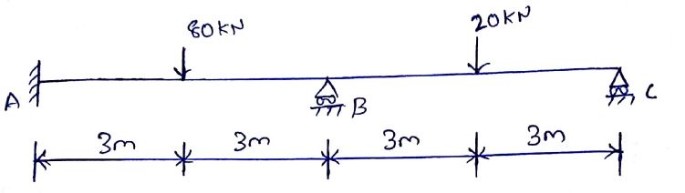 | [10M]
15. |  | Analyse the continuous beam shown below by using stiffness matrix method.  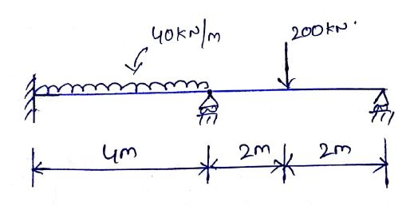 | [10M]
16. |  | Calculate the shape factor for of the I-section shown below. If the value of the yield stress is 250 N/mm², find the plastic moment capacity of the section.  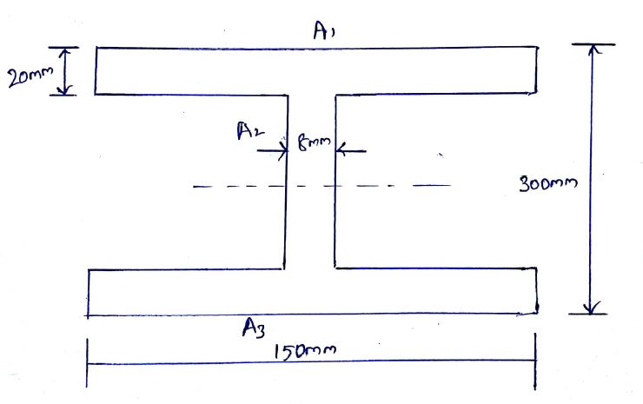 | [10M]
17. |  | Generate the stiffness matrix for cantilever beam considering axial deformation. | [10M]
18. |  | Calculate the plastic moment capacity and the collapse load for the beam shown below.  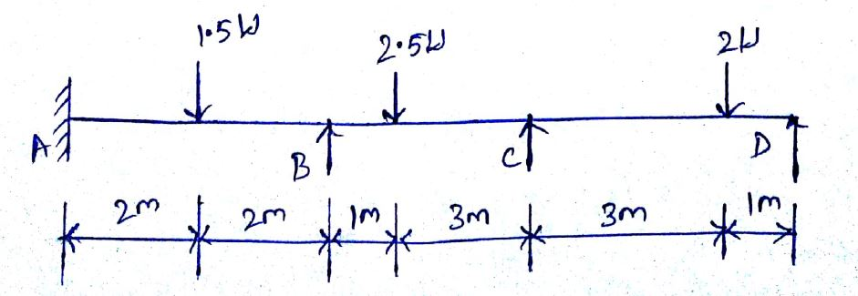 | [10M]

-- 00 -- 00 –

